COMSATS UNIVERSITY ISLAMABAD
ATTOCK CAMPUS

DEPARTMENT OF COMPUTER SCIENCE

COURSE | MAD
INSTRUCTOR | Sir Kamran
TASK | Assignment 02
Submitted By:
NAME | REGISTRATION NO.
Javeria Irum | FA23-BSE-063

Checking node.js:
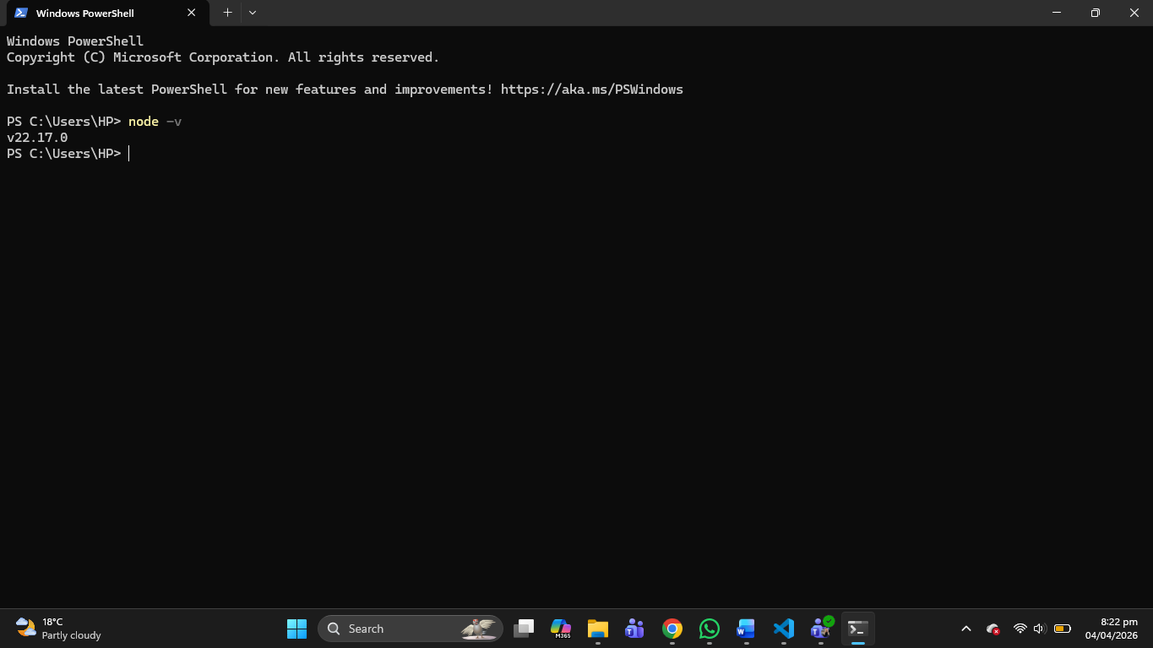
Creating Project Folder:
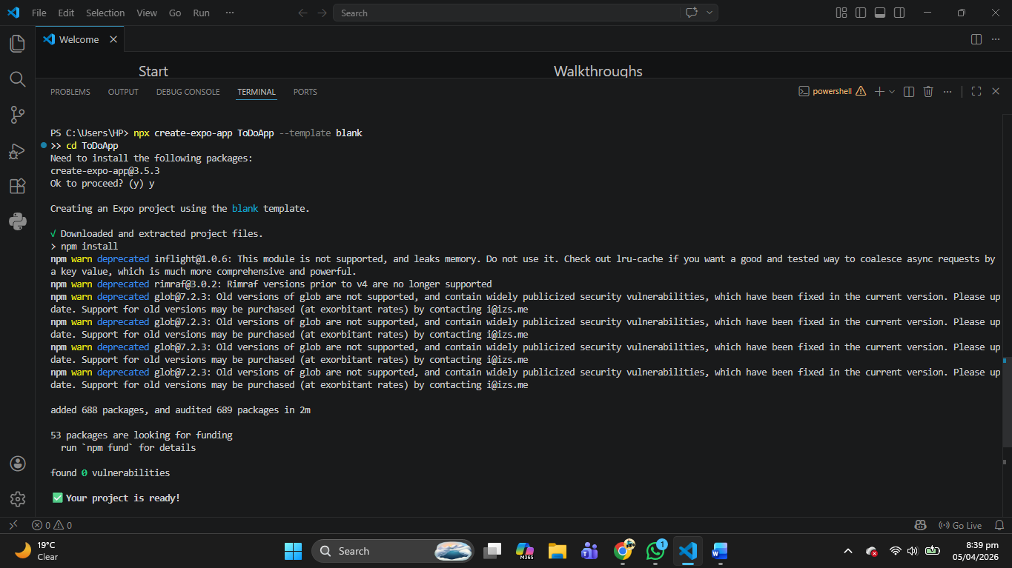

Code:
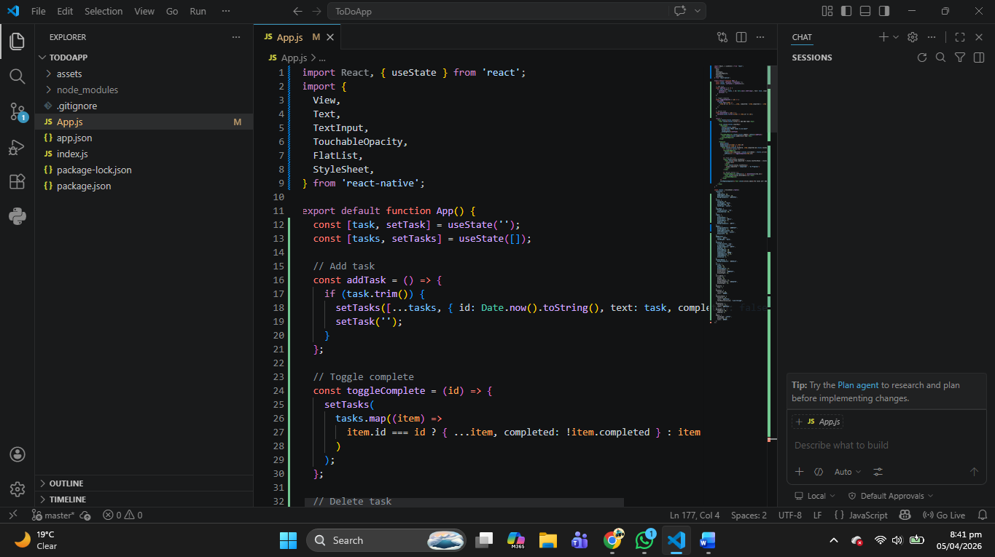
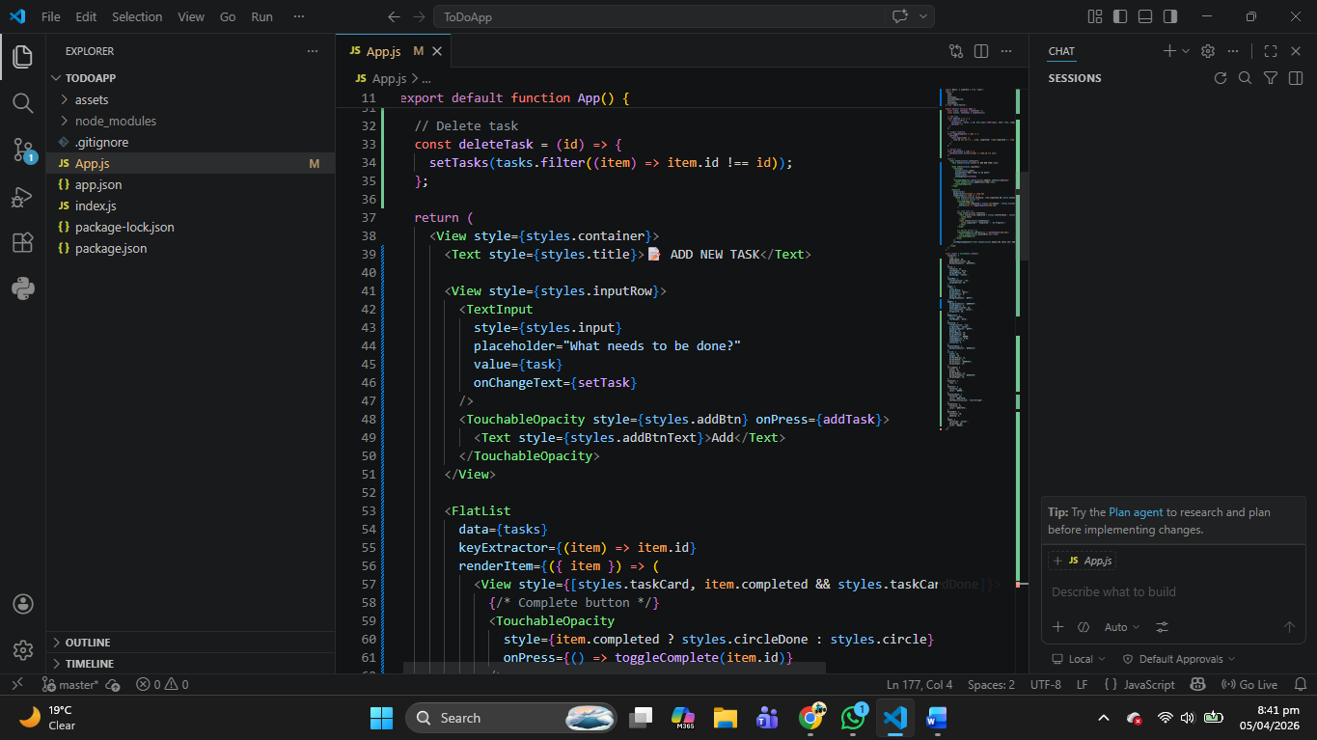
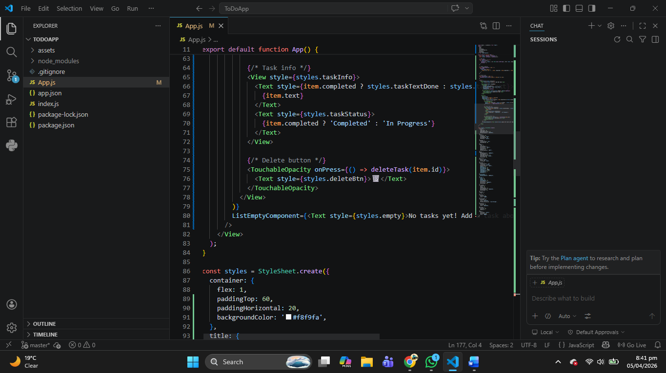
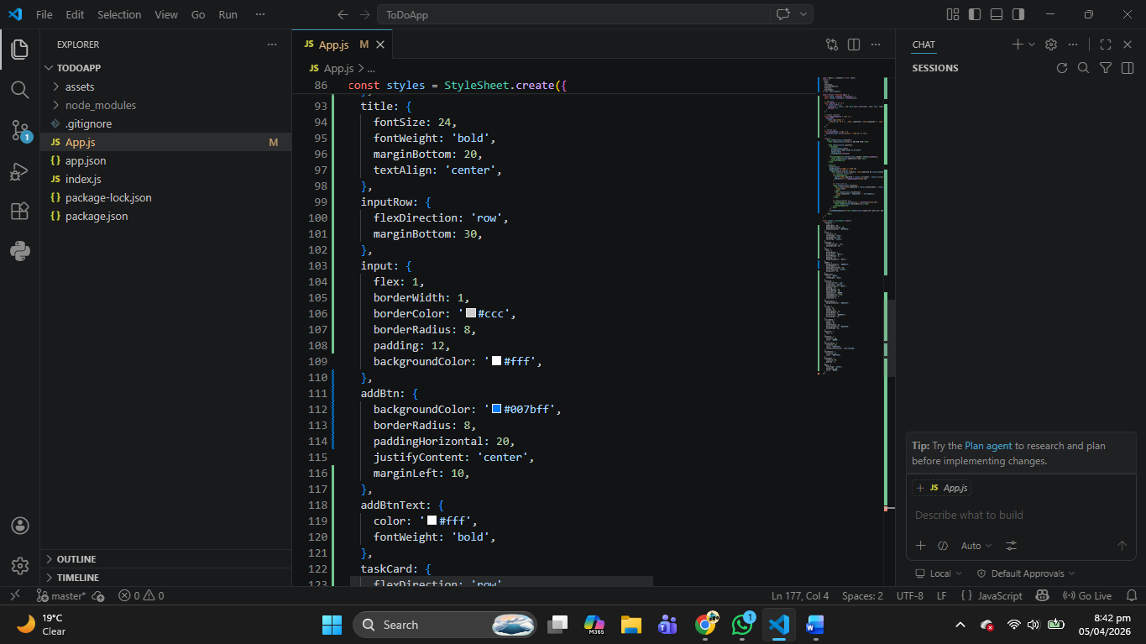
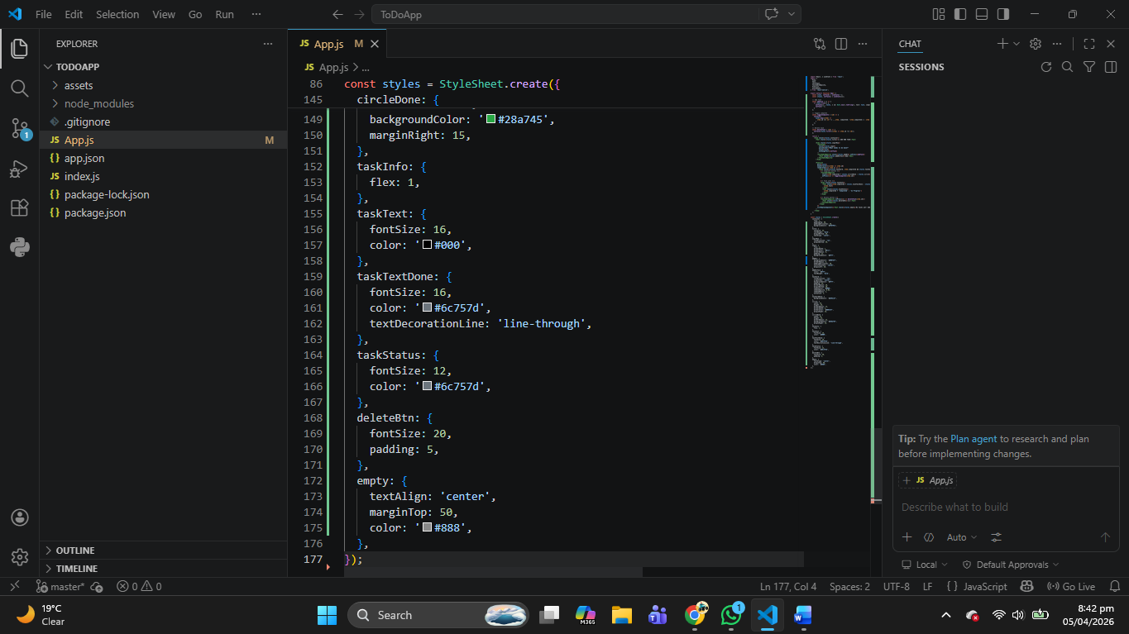
Run the project on Expo:
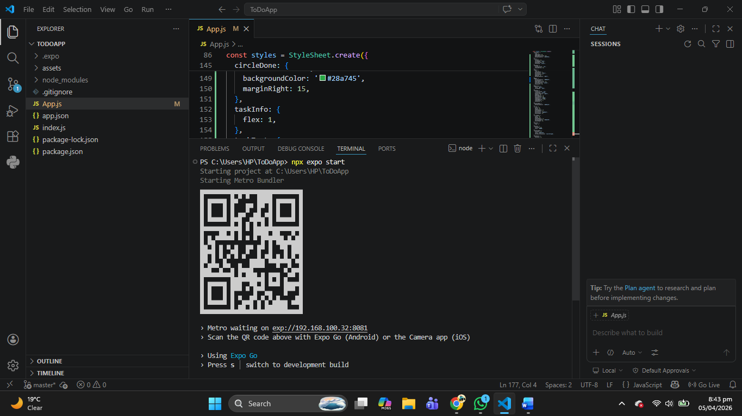

TODOAPP:
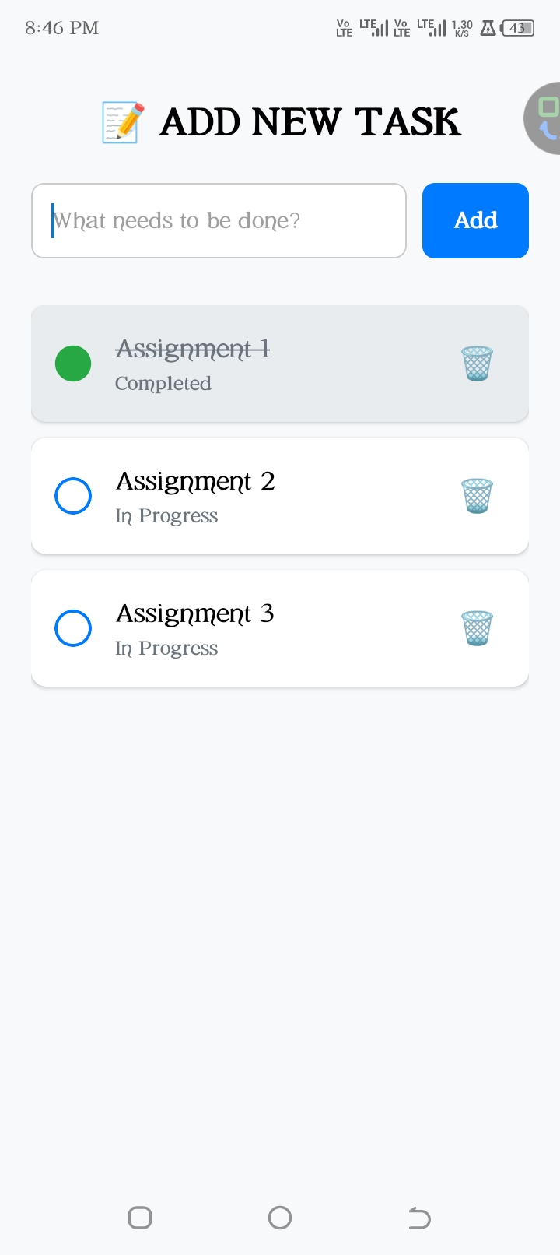

Improve APP:
